**Vijay Sales Shop**

**Database Management System**

**Overview:-**

Vijay Sales Shop is a retail business specializing in electronic products and home appliances. To effectively manage its operations, The Raw data of a SQL Database Management System (DBMS) is designed to handle essential aspects such as product inventory, sales transactions, customer data, supplier details, and purchase records.

The Vijay Sales database structure includes tables for:

1. **Products** - Details of all available products, their categories, brands, prices, and stock levels.
2. **Categories** - Classification of products for easy navigation and inventory organization.
3. **Brands** - Information about various brands and their origins.
4. **Customers** - Records of customer information for tracking purchases and enhancing customer service.
5. **Sales** - Transactional data for sales, including total amounts and payment methods.
6. **SalesDetails** - Breakdown of each sale, showing product quantity, sale price, and discounts.
7. **Inventory** - Tracks product availability across different store locations.
8. **Locations** - Information about each store location, including addresses.
9. **Suppliers** - Details of suppliers providing products, including contact and ordering information.
10. **Purchases** - Purchase orders from suppliers, including costs and order status.
11. **PurchaseDetails** - Specific details for each purchase order, such as product quantity and price.
12. **Payments** - Records of customer payments for sales and their statuses.

The SQL DBMS enables Vijay Sales Shop to maintain smooth operations by accurately tracking inventory, processing transactions efficiently, and managing supplier relations. This structure helps ensure real-time data availability for decision-making, improves customer service, and supports inventory control.

**Raw Diagram**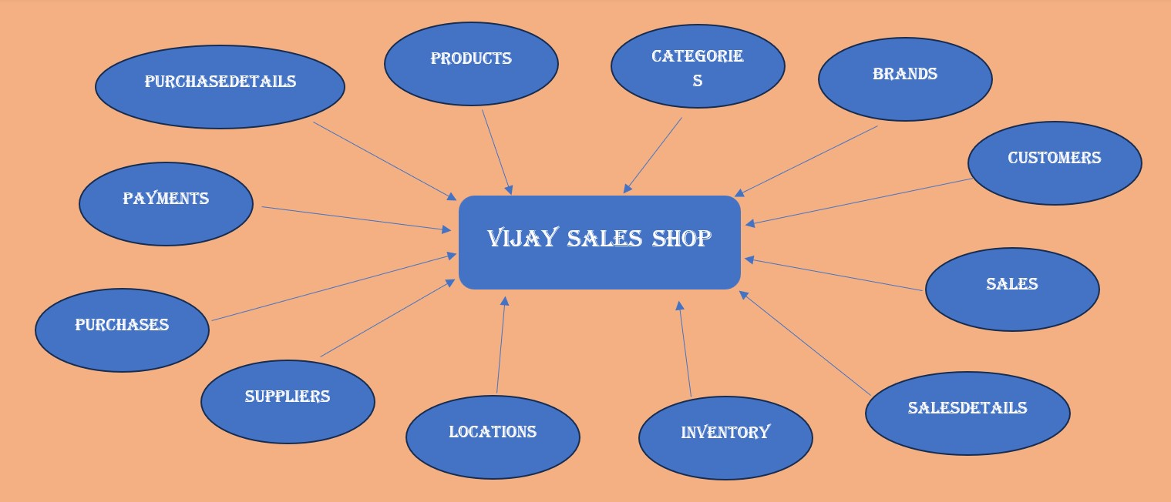

**ER Diagram**

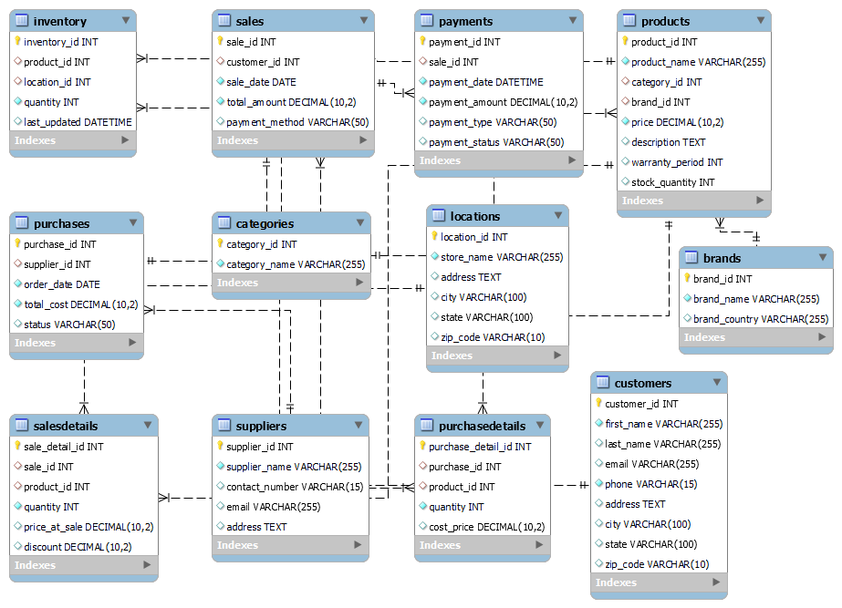

**Create Tables: -**

CReate database **vijay_sales_shop**;

use **vijay_sales_shop**;

-- 1. **Products**

CREATE TABLE **Products** (

product_id INT PRIMARY KEY AUTO_INCREMENT,

product_name VARCHAR(255) NOT NULL,

category_id INT,

brand_id INT,

price DECIMAL(10, 2) NOT NULL,

description TEXT,

warranty_period INT,

stock_quantity INT,

FOREIGN KEY (category_id) REFERENCES Categories(category_id),

FOREIGN KEY (brand_id) REFERENCES Brands(brand_id)

);

-- 2. **Categories**

CREATE TABLE **Categories** (

category_id INT PRIMARY KEY AUTO_INCREMENT,

category_name VARCHAR(255) NOT NULL

);

-- 3. **Brands**

CREATE TABLE **Brands** (

brand_id INT PRIMARY KEY AUTO_INCREMENT,

brand_name VARCHAR(255) NOT NULL,

brand_country VARCHAR(255)

);

-- 4. **Customers**

CREATE TABLE **Customers** (

customer_id INT PRIMARY KEY AUTO_INCREMENT,

first_name VARCHAR(255) NOT NULL,

last_name VARCHAR(255),

email VARCHAR(255) UNIQUE,

phone VARCHAR(15) NOT NULL,

address TEXT,

city VARCHAR(100),

state VARCHAR(100),

zip_code VARCHAR(10)

);

-- 5. **Sales**

CREATE TABLE **Sales** (

sale_id INT PRIMARY KEY AUTO_INCREMENT,

customer_id INT,

sale_date DATE NOT NULL,

total_amount DECIMAL(10, 2) NOT NULL,

payment_method VARCHAR(50),

FOREIGN KEY (customer_id) REFERENCES Customers(customer_id)

);

-- 6. **SalesDetails**

CREATE TABLE **SalesDetails** (

sale_detail_id INT PRIMARY KEY AUTO_INCREMENT,

sale_id INT,

product_id INT,

quantity INT NOT NULL,

price_at_sale DECIMAL(10, 2),

discount DECIMAL(10, 2),

FOREIGN KEY (sale_id) REFERENCES Sales(sale_id),

FOREIGN KEY (product_id) REFERENCES Products(product_id)

);

-- 7. **Inventory**

CREATE TABLE **Inventory** (

inventory_id INT PRIMARY KEY AUTO_INCREMENT,

product_id INT,

location_id INT,

quantity INT NOT NULL,

last_updated DATETIME,

FOREIGN KEY (product_id) REFERENCES Products(product_id),

FOREIGN KEY (location_id) REFERENCES Locations(location_id)

);

-- 8. **Locations**

CREATE TABLE **Locations** (

location_id INT PRIMARY KEY AUTO_INCREMENT,

store_name VARCHAR(255) NOT NULL,

address TEXT,

city VARCHAR(100),

state VARCHAR(100),

zip_code VARCHAR(10)

);

-- 9. **Suppliers**

CREATE TABLE **Suppliers** (

supplier_id INT PRIMARY KEY AUTO_INCREMENT,

supplier_name VARCHAR(255) NOT NULL,

contact_number VARCHAR(15),

email VARCHAR(255) UNIQUE,

address TEXT

);

-- 10. **Purchases**

CREATE TABLE **Purchases** (

purchase_id INT PRIMARY KEY AUTO_INCREMENT,

supplier_id INT,

order_date DATE NOT NULL,

total_cost DECIMAL(10, 2) NOT NULL,

status VARCHAR(50),

FOREIGN KEY (supplier_id) REFERENCES Suppliers(supplier_id)

);

-- 11. **PurchaseDetails**

CREATE TABLE **PurchaseDetails** (

purchase_detail_id INT PRIMARY KEY AUTO_INCREMENT,

purchase_id INT,

product_id INT,

quantity INT NOT NULL,

cost_price DECIMAL(10, 2),

FOREIGN KEY (purchase_id) REFERENCES Purchases(purchase_id),

FOREIGN KEY (product_id) REFERENCES Products(product_id)

);

-- 12. **Payments**

CREATE TABLE **Payments** (

payment_id INT PRIMARY KEY AUTO_INCREMENT,

sale_id INT,

payment_date DATETIME NOT NULL,

payment_amount DECIMAL(10, 2) NOT NULL,

payment_type VARCHAR(50),

payment_status VARCHAR(50),

FOREIGN KEY (sale_id) REFERENCES Sales(sale_id)

);

**Insert Values of all Tables**

* **Products**

INSERT INTO **Products** (product_id, product_name, category_id, brand_id, price, description, warranty_period, stock_quantity)

VALUES

(1, 'Samsung LED TV 43"', 1, 1, 29999.99, '43-inch LED TV with Full HD resolution', 24, 10),

(2, 'iPhone 14', 2, 2, 79999.99, '128GB, Midnight Black', 12, 15),

(3, 'Dell Inspiron Laptop', 3, 3, 45999.99, 'Core i5, 8GB RAM, 512GB SSD', 12, 8),

(4, 'Sony Headphones WH-1000XM4', 4, 4, 19999.99, 'Noise-canceling wireless headphones', 12, 20),

(5, 'LG Refrigerator 190L', 5, 5, 15999.99, '190L single-door refrigerator with smart inverter compressor', 24, 12),

(6, 'HP Pavilion Laptop 14"', 3, 6, 60999.99, 'Core i7, 16GB RAM, 1TB SSD', 12, 7),

(7, 'Canon EOS 1500D DSLR Camera', 6, 7, 35999.99, '24.1MP DSLR camera with dual-lens kit', 12, 5),

(8, 'Philips Air Fryer HD9216', 7, 8, 8499.99, 'Rapid Air Technology for healthier frying', 12, 18),

(9, 'Sony Bravia 55" LED TV', 1, 9, 54999.99, '4K UHD Smart LED TV with HDR and Android OS', 24, 15),

(10, 'Samsung Galaxy S21', 2, 2, 69999.99, '128GB storage, 8GB RAM, Exynos 2100', 12, 20),

(11, 'Dell Inspiron 15"', 3, 10, 48999.99, 'Core i5, 8GB RAM, 512GB SSD, Windows 10', 12, 10),

(12, 'Whirlpool Washing Machine 6.5kg', 5, 11, 17999.99, '6.5kg fully automatic front-load', 24, 8),

(13, 'Nikon D5600 DSLR Camera', 6, 12, 44999.99, '24.2MP DSLR with 18-55mm lens', 12, 5),

(14, 'Bajaj Microwave Oven 20L', 7, 13, 5999.99, 'Convection microwave with digital display', 12, 12);

* **Categories**

INSERT INTO **Categories** (category_id, category_name)

VALUES

(1, 'Television'),

(2, 'Mobile Phones'),

(3, 'Laptops'),

(4, 'Headphones'),

(5, 'Refrigerators'),

(6, 'Cameras'),

(7, 'Kitchen Appliances'),

(8, 'Microwaves'),

(9, 'Washing Machines');

* **Brands**

INSERT INTO **Brands** (brand_id, brand_name, brand_country)

VALUES

(1, 'Samsung', 'South Korea'),

(2, 'Apple', 'United States'),

(3, 'Dell', 'United States'),

(4, 'Sony', 'Japan'),

(5, 'LG', 'South Korea'),

(6, 'HP', 'United States'),

(7, 'Canon', 'Japan'),

(8, 'Philips', 'Netherlands'),

(9, 'Sony', 'Japan'),

(10, 'Dell', 'United States'),

(11, 'Whirlpool', 'United States'),

(12, 'Nikon', 'Japan'),

(13, 'Bajaj', 'India');

* **Customers**

INSERT INTO **Customers** (customer_id, first_name, last_name, email, phone, address, city, state, zip_code)

VALUES

(1, 'Ravi', 'Sharma', 'ravi.sharma@gmail.com', '9123456789', '123 Main Street', 'Mumbai', 'Maharashtra', '400001'),

(2, 'Anita', 'Verma', 'anita.verma@gmail.com', '9234567890', '456 Park Avenue', 'Pune', 'Maharashtra', '411001'),

(3, 'Raj', 'Patel', 'raj.patel@gmail.com', '9345678901', '789 Hill Road', 'Surat', 'Gujarat', '395007'),

(4, 'Priya', 'Kumar', 'priya.kumar@gmail.com', '9456123456', 'Apartment 42, Sector 22', 'Noida', 'Uttar Pradesh', '201301'),

(5, 'Amit', 'Singh', 'amit.singh@gmail.com', '9561234567', 'Bungalow 19, Shivaji Nagar', 'Nagpur', 'Maharashtra', '440010'),

(6, 'Neha', 'Joshi', 'neha.joshi@gmail.com', '9671234568', 'Flat 13B, Race Course Road', 'Indore', 'Madhya Pradesh', '452001'),

(7, 'Rajesh', 'Patel', 'rajesh.patel@gmail.com', '9876543210', 'House 29, MG Road', 'Pune', 'Maharashtra', '411001'),

(8, 'Suman', 'Sharma', 'suman.sharma@gmail.com', '9765432189', 'Apartment 4A, South City', 'Kolkata', 'West Bengal', '700047'),

(9, 'Akhil', 'Verma', 'akhil.verma@gmail.com', '8896541234', 'Building 21, Banjara Hills', 'Hyderabad', 'Telangana', '500034');

* **Sales**

INSERT INTO **Sales** (sale_id, customer_id, sale_date, total_amount, payment_method)

VALUES

(1, 1, '2024-10-01', 109999.97, 'Credit Card'),

(2, 2, '2024-10-02', 79999.99, 'Debit Card'),

(3, 3, '2024-10-03', 29999.99, 'Cash'),

(4, 4, '2024-10-04', 15999.99, 'UPI'),

(5, 5, '2024-10-05', 60999.99, 'Credit Card'),

(6, 6, '2024-10-06', 8499.99, 'Debit Card'),

(7, 7, '2024-10-07', 54999.99, 'Credit Card'),

(8, 8, '2024-10-08', 69999.99, 'UPI'),

(9, 9, '2024-10-09', 17999.99, 'Cash');

* **SalesDetails**

INSERT INTO **SalesDetails** (sale_detail_id, sale_id, product_id, quantity, price_at_sale, discount)

VALUES

(1, 1, 1, 1, 29999.99, 0),

(2, 1, 2, 1, 79999.99, 0),

(3, 2, 2, 1, 79999.99, 0),

(4, 3, 1, 1, 29999.99, 0),

(5, 4, 5, 1, 15999.99, 500),

(6, 5, 6, 1, 60999.99, 0),

(7, 6, 8, 1, 8499.99, 200),

(8, 7, 9, 1, 54999.99, 0),

(9, 8, 10, 1, 69999.99, 2000),

(10, 9, 12, 1, 17999.99, 500);

* **Inventory**

INSERT INTO **Inventory** (inventory_id, product_id, location_id, quantity, last_updated)

VALUES

(1, 1, 1, 10, '2024-10-01'),

(2, 2, 1, 15, '2024-10-01'),

(3, 3, 2, 8, '2024-10-01'),

(4, 4, 2, 20, '2024-10-01'),

(5, 5, 1, 12, '2024-10-04'),

(6, 6, 1, 7, '2024-10-05'),

(7, 7, 2, 5, '2024-10-06'),

(8, 8, 2, 18, '2024-10-06'),

(9, 9, 3, 15, '2024-10-07'),

(10, 10, 2, 20, '2024-10-08'),

(11, 11, 1, 10, '2024-10-09'),

(12, 12, 2, 8, '2024-10-09');

* **Locations**

INSERT INTO **Locations** (location_id, store_name, address, city, state, zip_code)

VALUES

(1, 'Vijay Sales - Andheri', 'Plot 21, Andheri West', 'Mumbai', 'Maharashtra', '400053'),

(2, 'Vijay Sales - Bandra', 'Shop No. 10, Linking Road', 'Mumbai', 'Maharashtra', '400050'),

(3, 'Vijay Sales - Thane', 'Shop No. 22, Ghodbunder Road', 'Thane', 'Maharashtra', '400601'),

(4, 'Vijay Sales - Vashi', 'Plot 5, Sector 17', 'Navi Mumbai', 'Maharashtra', '400703'),

(5, 'Vijay Sales - Andheri', 'Plot No. 9, Andheri West', 'Mumbai', 'Maharashtra', '400058'),

(6, 'Vijay Sales - Kandivali', 'Station Road, Kandivali East', 'Mumbai', 'Maharashtra', '400101');

* **Suppliers**

INSERT INTO **Suppliers** (supplier_id, supplier_name, contact_number, email, address)

VALUES

(1, 'Samsung Electronics', '9876543210', 'contact@samsung.com', 'Seoul, South Korea'),

(2, 'Apple Inc.', '9765432109', 'sales@apple.com', 'Cupertino, CA, USA'),

(3, 'Dell India', '9654321098', 'info@dell.com', 'Bangalore, Karnataka, India'),

(4, 'LG Electronics', '9988776655', 'lg@lgelectronics.com', 'Seoul, South Korea'),

(5, 'HP India', '9876543212', 'info@hp.com', 'Bengaluru, Karnataka, India'),

(6, 'Canon India', '9765432107', 'support@canon.in', 'Noida, Uttar Pradesh, India'),

(7, 'Philips India', '9654321096', 'service@philips.com', 'Gurgaon, Haryana, India'),

(8, 'Sony India', '9898989898', 'support@sony.co.in', 'Tokyo, Japan'),

(9, 'Whirlpool India', '9797979797', 'contact@whirlpool.com', 'Pune, Maharashtra, India'),

(10, 'Nikon India', '9696969696', 'service@nikon.in', 'Tokyo, Japan'),

(11, 'Bajaj Electricals', '9595959595', 'support@bajajelectricals.com', 'Mumbai, Maharashtra, India');

* **Purchases**

INSERT INTO **Purchases** (purchase_id, supplier_id, order_date, total_cost, status)

VALUES

(1, 1, '2024-09-01', 250000.00, 'Ordered'),

(2, 2, '2024-09-10', 500000.00, 'Received'),

(3, 3, '2024-09-15', 150000.00, 'Ordered'),

(4, 4, '2024-10-04', 120000.00, 'Ordered'),

(5, 5, '2024-10-05', 250000.00, 'Received'),

(6, 6, '2024-10-06', 180000.00, 'Ordered'),

(7, 8, '2024-10-07', 400000.00, 'Ordered'),

(8, 9, '2024-10-08', 150000.00, 'Received'),

(9, 10, '2024-10-09', 250000.00, 'Pending');

* **PurchaseDetails**

INSERT INTO **PurchaseDetails** (purchase_detail_id, purchase_id, product_id, quantity, cost_price)

VALUES

(1, 1, 1, 10, 25000.00),

(2, 2, 2, 5, 75000.00),

(3, 3, 3, 3, 50000.00),

(4, 4, 5, 10, 12000.00),

(5, 5, 6, 5, 50000.00),

(6, 6, 7, 3, 60000.00),

(7, 7, 9, 8, 45000.00),

(8, 8, 12, 6, 12000.00),

(9, 9, 13, 4, 40000.00);

* **Payments**

INSERT INTO **Payments** (payment_id, sale_id, payment_date, payment_amount, payment_type, payment_status)

VALUES

(1, 1, '2024-10-01', 109999.97, 'Credit Card', 'Completed'),

(2, 2, '2024-10-02', 79999.99, 'Debit Card', 'Completed'),

(3, 3, '2024-10-03', 29999.99, 'Cash', 'Completed'),

(4, 4, '2024-10-04', 15999.99, 'UPI', 'Completed'),

(5, 5, '2024-10-05', 60999.99, 'Credit Card', 'Completed'),

(6, 6, '2024-10-06', 8499.99, 'Debit Card', 'Completed'),

(7, 7, '2024-10-07', 54999.99, 'Credit Card', 'Completed'),

(8, 8, '2024-10-08', 69999.99, 'UPI', 'Completed'),

(9, 9, '2024-10-09', 17999.99, 'Cash', 'Completed');

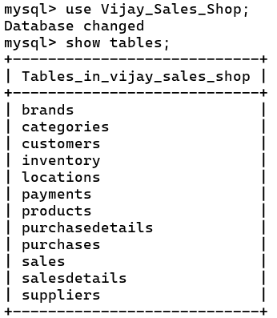*** **Select & Desc** ***

select * from **Products**;

select * from **Suppliers**;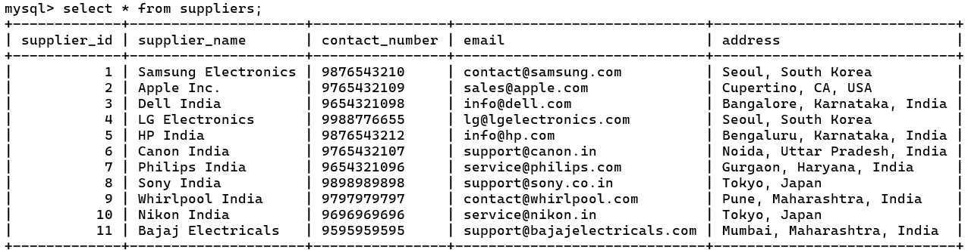

select * from **Purchases**;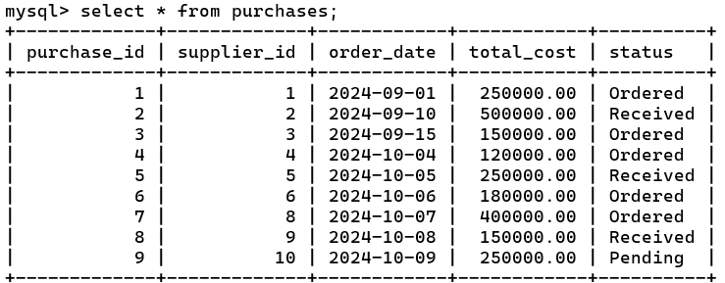

**DESC**

*** **Questions** ***

-- How many SHop are in Mumbai?

SELECT store_name, address ,city

FROM locations

-- How many customers are from Mumbai?

SELECT first_name, last_name ,city,state

FROM Customers

-- How many Brands are from Japan?

SELECT Brand_name

FROM Brands

WHERE brand_country = 'Japan'

-- find all products with names that start with "Samsung":

SELECT * FROM Products

WHERE product_name LIKE 'Samsung%';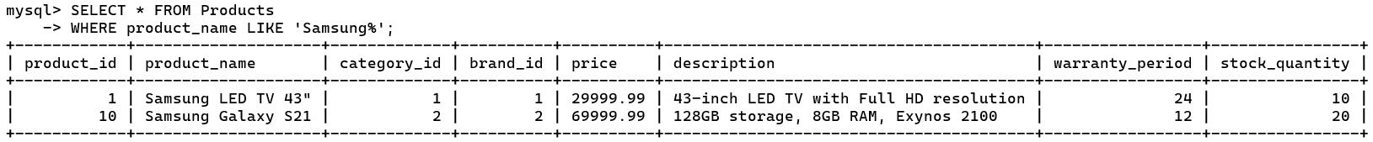

-- find all products where the second character in the name is "a":

SELECT * FROM Products

-- find all products that contain "Laptop" in their name:

SELECT * FROM Products

WHERE product_name LIKE '%Laptop%';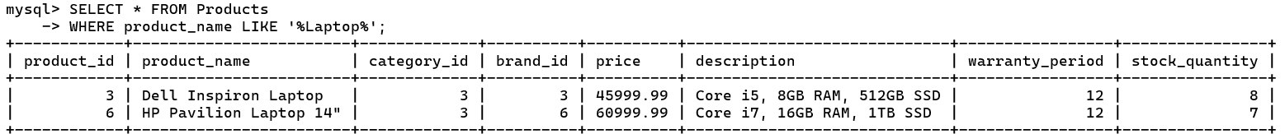

-- What are the first names, last names, and email addresses of customers

-- whose first names start with the letter "A"?

SELECT first_name, last_name, email

FROM Customers

-- What is the total revenue generated from sales?

SELECT SUM(total_amount) AS total_revenue

-- What is the total number of customers and the total sales amount?

SELECT (SELECT COUNT(*) FROM Customers) AS total_customers,

-- What is the list of all products along with their category, brand, price, and stock quantity?

SELECT

p.product_name,

c.category_name,

b.brand_name,

p.price,

p.stock_quantity

FROM Products p

JOIN Categories c ON p.category_id = c.category_id

-- Which products are currently below 8 stocks?

SELECT product_name

FROM Products

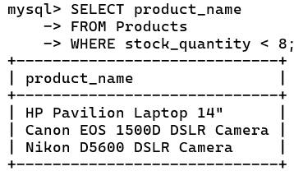WHERE stock_quantity < 8;

-- What is the total amount spent by each customer?

SELECT

c.first_name,

c.last_name,

SUM(s.total_amount) AS total_spent

FROM Sales s

JOIN Customers c ON s.customer_id = c.customer_id

-- What is the total quantity sold and total revenue for each product?

SELECT

p.product_name,

SUM(sd.quantity) AS total_quantity_sold,

SUM(sd.price_at_sale * sd.quantity) AS total_revenue

FROM SalesDetails sd

JOIN Products p ON sd.product_id = p.product_id

-- Who are the top 5 customers based on total purchase amount?

SELECT

c.first_name,

c.last_name,

SUM(s.total_amount) AS total_spent

FROM Sales s

JOIN Customers c ON s.customer_id = c.customer_id

GROUP BY c.customer_id, c.first_name, c.last_name

ORDER BY total_spent DESC

LIMIT 5;

-- What is the inventory count for each product across all store locations?

SELECT

l.store_name,

p.product_name,

i.quantity AS stock_quantity

FROM Inventory i

JOIN Products p ON i.product_id = p.product_id

JOIN Locations l ON i.location_id = l.location_id;

-- How much revenue is generated by each payment method?

SELECT

payment_method,

SUM(total_amount) AS total_revenue

FROM Sales

-- What is the average discount offered on each product?

SELECT

p.product_name,

AVG(sd.discount) AS average_discount

FROM SalesDetails sd

JOIN Products p ON sd.product_id = p.product_id

GROUP BY p.product_name;

-- List the suppliers and the status of their latest purchase orders.

SELECT s.supplier_name,

p.order_date,

p.status

FROM Purchases p

JOIN Suppliers s ON p.supplier_id = s.supplier_id

ORDER BY s.supplier_name, p.order_date DESC;

-- Which products have stock below 10 units?

SELECT

product_name,

stock_quantity

FROM Products

-- What are the sales made between specific dates?

SELECT sale_id, customer_id, sale_date, total_amount

FROM Sales

WHERE sale_date BETWEEN '2024-10-01' AND '2024-10-31';

-- What products has a specific customer purchased?

SELECT

c.first_name,

c.last_name,

p.product_name,

sd.quantity,

sd.price_at_sale

FROM SalesDetails sd

JOIN Sales s ON sd.sale_id = s.sale_id

JOIN Customers c ON s.customer_id = c.customer_id

JOIN Products p ON sd.product_id = p.product_id

-- What are the contact details of all customers?

-- Which products have generated the highest revenue?

SELECT p.product_name,

SUM(sd.price_at_sale * sd.quantity) AS total_revenue

FROM SalesDetails sd

JOIN Products p ON sd.product_id = p.product_id

GROUP BY p.product_name

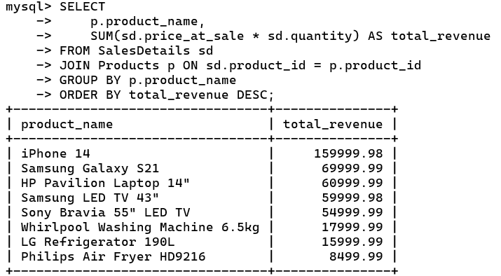ORDER BY total_revenue DESC;

-- How many sales were made each month?

SELECT DATE_FORMAT(sale_date, '%Y-%m') AS month,

COUNT(sale_id) AS total_sales

FROM Sales

GROUP BY month

ORDER BY month;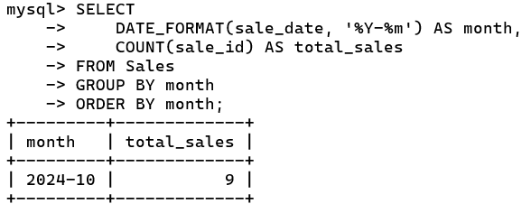

-- What is the total sales amount for each product category?

SELECT c.category_name,

SUM(s.total_amount) AS total_sales

FROM Sales s

JOIN SalesDetails sd ON s.sale_id = sd.sale_id

JOIN Products p ON sd.product_id = p.product_id

JOIN Categories c ON p.category_id = c.category_id

GROUP BY c.category_name;

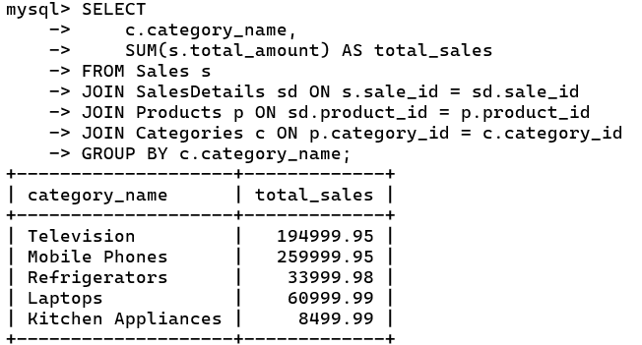

-- How many purchases has each customer made?

SELECT

c.first_name,

c.last_name,

COUNT(s.sale_id) AS purchase_count

FROM Customers c

LEFT JOIN Sales s ON c.customer_id = s.customer_id

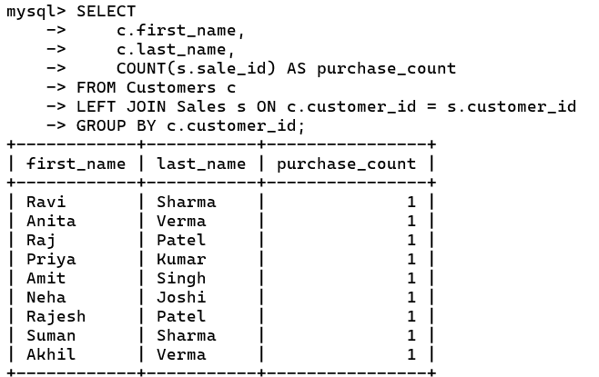GROUP BY c.customer_id;

-- Which products are currently being offered at a discount?

SELECT

p.product_name,

sd.discount

FROM SalesDetails sd

JOIN Products p ON sd.product_id = p.product_id

WHERE sd.discount > 0;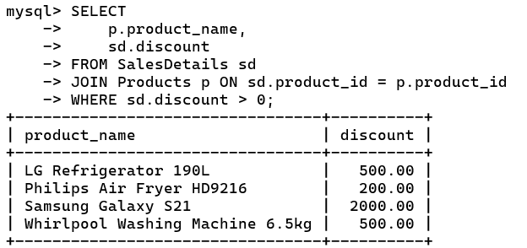

-- What is the total revenue generated each month?

SELECT DATE_FORMAT(s.sale_date, '%Y-%m') AS month,

SUM(s.total_amount) AS total_revenue

FROM Sales s

GROUP BY month

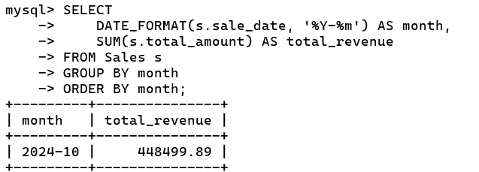ORDER BY month;

-- Which suppliers have pending purchase orders?

SELECT

s.supplier_name,

p.order_date,

p.status

FROM Purchases p

JOIN Suppliers s ON p.supplier_id = s.supplier_id

WHERE p.status = 'Pending';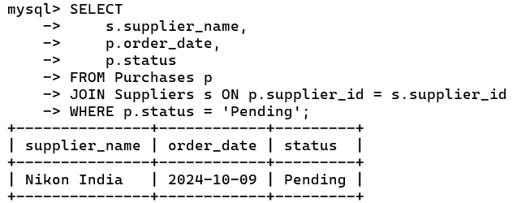

-- What is the total sales amount for each brand?

SELECT

b.brand_name,

SUM(s.total_amount) AS total_sales

FROM Sales s

JOIN SalesDetails sd ON s.sale_id = sd.sale_id

JOIN Products p ON sd.product_id = p.product_id

JOIN Brands b ON p.brand_id = b.brand_id

GROUP BY b.brand_name;

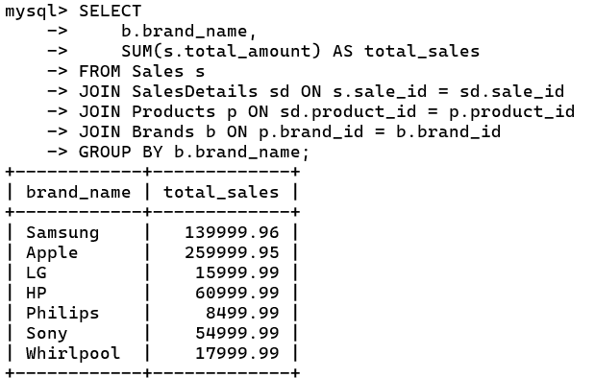

-- Which products have the highest number of sales?

SELECT

p.product_name,

COUNT(sd.sale_id) AS number_of_sales

FROM SalesDetails sd

JOIN Products p ON sd.product_id = p.product_id

GROUP BY p.product_name

ORDER BY number_of_sales DESC;

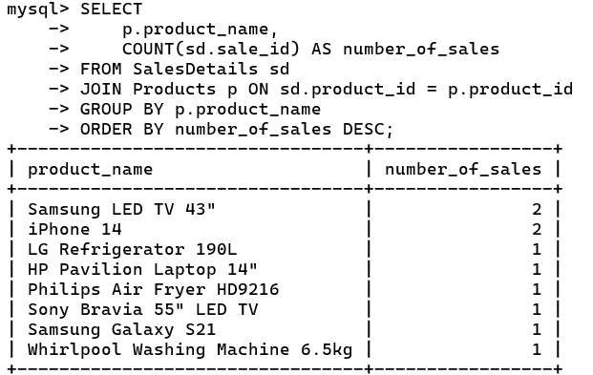

-- What is the average order value across all sales?

SELECT AVG(total_amount) AS average_order_value

FROM Sales;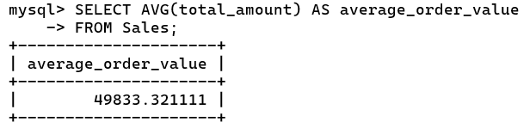

-- What is the spending trend of customers over the last six months?

SELECT

DATE_FORMAT(s.sale_date, '%Y-%m') AS month,

SUM(s.total_amount) AS total_spent

FROM Sales s

WHERE s.sale_date >= DATE_SUB(CURDATE(), INTERVAL 6 MONTH)

GROUP BY month

ORDER BY month;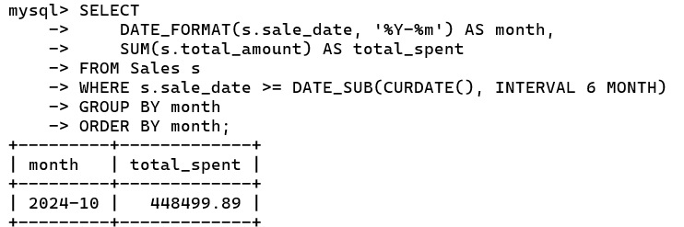

-- What is the total value of stock for each product?

SELECT

p.product_name,

(p.price * p.stock_quantity) AS total_stock_value

FROM Products p;

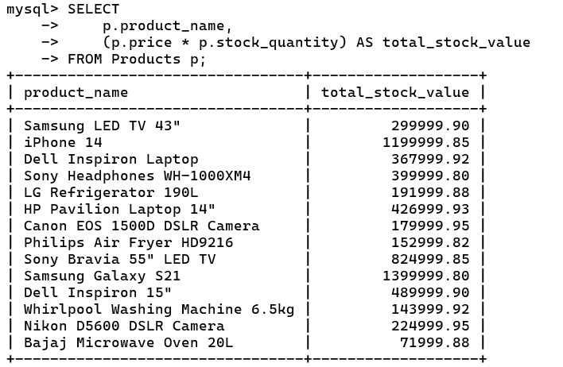

**Conclusion** : -

The **Vijay Sales** SQL Database Management System (DBMS) provides a structured and efficient way to manage the essential operations of a retail business specializing in electronics and home appliances. By organizing data into well-defined tables—such as Products, Categories, Brands, Customers, Sales, Inventory, Locations, Suppliers, Purchases, and Payments—the database facilitates streamlined management of inventory, customer transactions, supplier relations, and financial records.

This robust system allows for real-time tracking of product availability, detailed sales analysis, customer insights, and efficient handling of supplier orders. The database enables Vijay Sales to make data-driven decisions, improving operational efficiency, customer service, and profitability. Additionally, with easy access to comprehensive transaction data and inventory control, Vijay Sales can respond quickly to market demands and customer needs, positioning it well for continued growth and success in a competitive retail environment.

***********************

**\*\*\* THE END \*\*\***

***********************